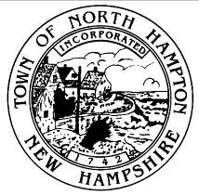

**TOWN OF NORTH HAMPTON**

**select board agenda**

special meeting – 03 DECEMBER 2014 –7:00 O’CLOCK P.M.

NORTH HAMPTON TOWN HALL

231 aTLANTIC aVENUE

nORTH hAMPTON, nEW hAMPSHIRE

Purpose: The purpose of the Special Meeting is to meet with the North Hampton Municipal Budget Committee to discuss the proposed FY 2016 Operating Budget. The meeting is a regular session of the Budget Committee and will be conducted pursuant to that Committee’s Rules of Procedure unless circumstances otherwise require.

1. Call to Order by the Chair, Mr. Maggiore.
2. Discussion with Budget Committee regarding Proposed Operating Budget for FY 2016
3. Any Other Item that may legally come before the Board

The Board reserves the right to take action on any item relative to the prudential administration of the Town’s affairs which circumstances may require.

1. Adjournment